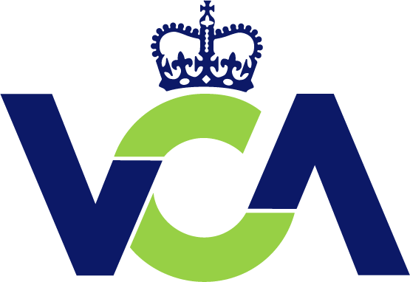 | application for a VEHICLE system & component APPROVAL FROM VCA  Please read the guidance notes before completing this application form
PART A - CUSTOMER’S DETAILS
Must be completed by all new customers or if any of the details have changed since your last application
1 VCA job number to be allocated by VCA : K??xxxxxx
2 Manufacturer’s name and address (owner of the approval who controls the product specification & has responsibility for CoP at the plants listed in item 6 below): | 3 Name and address of the applicant (if not the manufacturer):

4 Address for invoicing:  Contact name:  Telephone number:  Fax number:  E-mail address: | 5 Address for communications relating to CoP:  Contact name:  Telephone number:  Fax number:  E-mail address:

6. Please quote two credit referees
Name and Address: Name and Address:

Contact name: Contact name:
Telephone number: Telephone number:
Fax number: Fax number:
e-mail address: e-mail address:
Referees company Referees company
registration number: registration number:

Continued overleaf…

7.List of plants at which the products are manufactured and their VCA Conformity of Production (CoP) clearance reference:

8. For monitoring purposes, please give details of where you first heard about VCA.

